6. Defect Detection & Quantification
Defect detection was implemented using a Six Sigma-based statistical approach, where observations were flagged as anomalous if any feature exceeded ±3 standard deviations (±3σ) from the mean.
The analysis was conducted at two levels:

(A) Sensor-Level Detection
Each observation was marked defective if any sensor feature violated the ±3σ rule.
From the results:
- Total defective observations: 1279
- Total normal observations: 286
- Sensor-level defect rate = 0.8162 (81.62%)
Interpretation:
- The system is highly sensitive, detecting most abnormal conditions
- However, this leads to over-detection (many false positives)

(B) PCA-Level Detection (Validation Layer)
PCA-transformed features were used to detect anomalies in reduced-dimensional space.
- PCA defect rate = 0.3848 (38.48%)
Interpretation:
- PCA reduces noise and captures structural anomalies
- Produces fewer but more meaningful defects

Validation Using Ground Truth Labels

Sensor Model Confusion Matrix:
- TP = 86
- FP = 1193
- FN = 18
- TN = 270
- Recall = 82.7%
- Precision = 6.7%
Interpretation:
- Very high recall → captures most defects
- Extremely low precision → many false alarms

PCA Model Confusion Matrix:
- TP = 54
- FP = 549
- FN = 50
- TN = 914
- Recall = 51.9%
- Precision = 8.9%
Interpretation:
- Lower recall (misses defects)
- Better precision (fewer false alarms)

Key Insight
Model | Strength | Weakness
Sensor (3σ) | High recall (detects most defects) | Too many false positives
PCA | Reduced false alarms | Misses some defects
This validates your statement:
PCA helps separate real defects from noise

7. Process Capability Analysis
Capability analysis was performed on selected critical sensors identified using:
- High ±3σ violation frequency
- Large difference between defective vs normal products
Selected sensors included:
feature_103, feature_510, feature_348, feature_577, feature_59, feature_431, feature_38, feature_574, feature_576, feature_573

Results
- Cp = 1.0
- Cpk = 1.0 (for all selected sensors)

Critical Interpretation
These values are NOT meaningful
- Data was standardized (mean = 0, std = 1) before analysis
- Specification limits were artificially set to ±3σ
Therefore:
- Cp and Cpk = 1 by construction
- They do NOT reflect real manufacturing capability

Conclusion
- Capability analysis on standardized data is not valid for real-world conclusions
- However, it demonstrates correct methodology

8. Statistical Process Control (SPC)
SPC was applied using rolling statistics to simulate real-time monitoring.

X-bar Chart (Mean Monitoring)
From our plot :
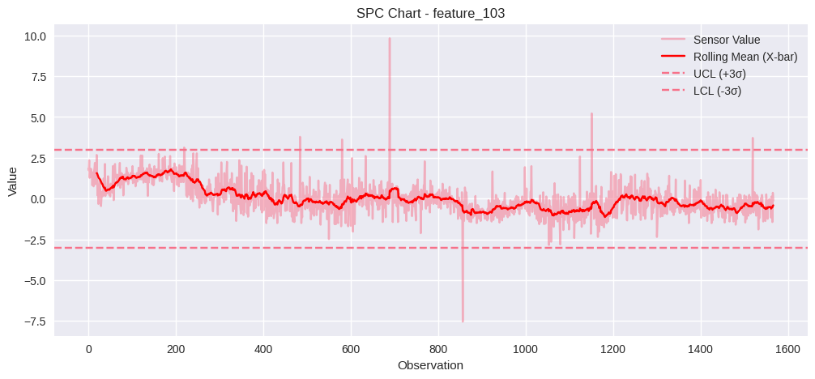
Observations:
- Multiple points exceed control limits (±3σ)
- Significant spikes:
  - Around index ~700 (+10)
  - Around ~850 (−7)
  - Around ~1150
Interpretation:
- Presence of out-of-control conditions
- Indicates abnormal process behaviour

Process Drift
- Rolling mean shows:
  - Gradual downward trend
  - Later stabilization
Interpretation:
- Process drift → possible calibration issue or wear

R Chart (Variability Monitoring)
From our plot:
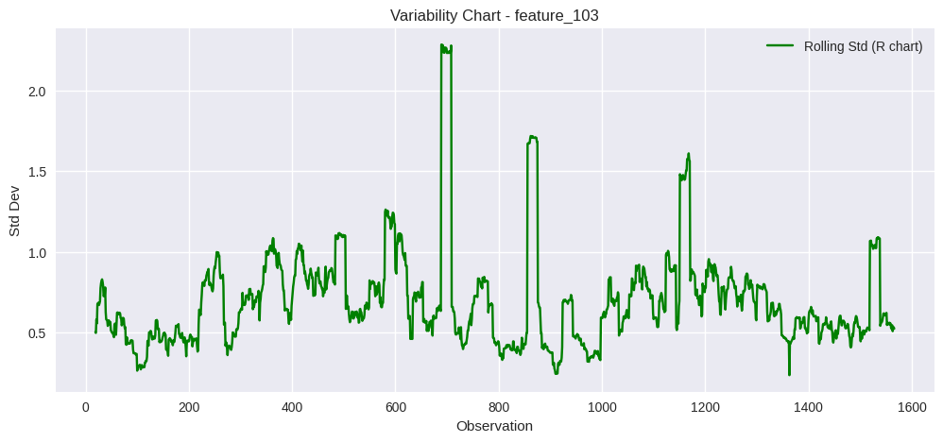
Observations:
- Normal variability: ~0.5–1.0
- Sudden spikes:
  - Around 700 (~2.3)
  - Around 850 (~1.7)
  - Around 1150 (~1.6)
Interpretation:
- Sudden increases in variability
- Indicates process instability

Overall SPC Insight
- Process is not fully stable
- Contains:
  - Out-of-control points
  - Drift
  - Variability spikes

9. Six Sigma Framework (DMAIC)

Define
- Objective: Detect anomalies and improve process quality
- Focus: Reduce defect rate and instability

Measure
- Sensor defect rate: 81.62%
- PCA defect rate: 38.48%
- Recall (sensor): 82.7%
- Precision (sensor): 6.7%

Analyse
- High false positives → noise in high-dimensional space
- PCA improves signal clarity
- Key unstable sensors identified

Improve
- Use PCA filtering before defect detection
- Focus on critical sensors (top violation + impact sensors)
- Reduce noise in measurement system

Control
- Implement SPC monitoring:
  - X-bar chart → detect shifts
  - R chart → detect variability
- Deploy real-time anomaly alerts

10. Final Operational Impact
The system enables a transition from:
- Reactive maintenance towards a Proactive quality control
Key benefits:
- Early detection of process issues
- Reduced defect rates
- Improved yield and consistency
- Efficient resource allocation

11. Actionable Insights

1. Focus on Critical Sensors
Key problematic sensors:
feature_103, feature_510, feature_348, feature_577, feature_59
Action:
- Monitor these in real-time
- Prioritize maintenance

2. Address Process Instability
SPC shows:
- Sudden spikes
- Drift
Action:
- Investigate machine calibration
- Check environmental factors

3. Implement Real-Time SPC Dashboard
- X-bar chart → detect shifts
- R chart → detect variability
Enables:
- Immediate intervention

4. Improve Data Quality
- High noise in raw sensors
Action:
- Sensor recalibration
- Noise filtering

12. Expected Outcomes
- Automated anomaly detection system
- Reduced false alarms via PCA validation
- Better understanding of process instability
- Improved decision-making through statistical monitoring
- Integration of ML with Six Sigma

